Topic | Date and Time
Grocery Shopping and Easy Recipes | Sept 3rd 11:00am
Inflammation | Sept 10th 11:00am
Mediterranean and DASH diets | Sept 17th 11:00am
Blood Glucose Management | Sept 24th 11:00am
Whole Food Plant Based Eating & the Microbiome | Oct 1st 11:00am
Mindful Eating | Oct 8th 11:00am
Grocery Shopping and Easy Recipes | Oct 15th 11:00am
Inflammation | Oct 22nd 11:00am
Mediterranean and DASH diets | Oct 29th 11:00am
Blood Glucose Management | Nov 5th 11:00am
Whole Food Plant Based Eating & the Microbiome | Nov 12th 11:00am
Heart Health Nutrition Education

Join zoom meeting by entering meeting ID and passcode:
- Meeting ID: 949 8356 5416

- Passcode: 440385

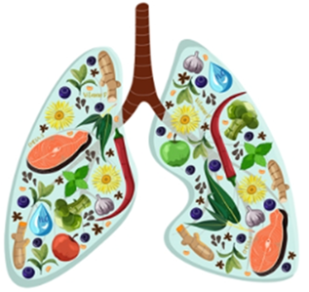
Pulmonary Health Nutrition Education

Join zoom meeting by entering meeting ID and passcode:
- Meeting ID: 949 8356 5416
- Passcode: 440385

Topic | Date and Time
Nutrition after Lung Transplant | Sep 27th 10:00am
Nutrition for ILD and COPD | Oct 25th 10:00am
Nutrition and COVID-19 | Nov 22nd 10:00am

