M | MOVEMENT/AMBULATION  - Week #1-Short frequent walks around the home, using walker  - Week #2-4 Gradually increase distance, starting on level ground  - Use the walker until no longer needing any support, without limp | 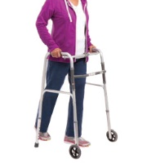
E | ELEVATE  - Use the TKA pillow (or stacked pillows-pictured) whenever resting  - Sleep in the pillow at night, unless it keeps you awake  - DO NOT keep the leg hanging down >15 minutes at a time | 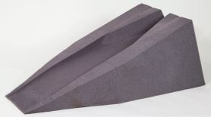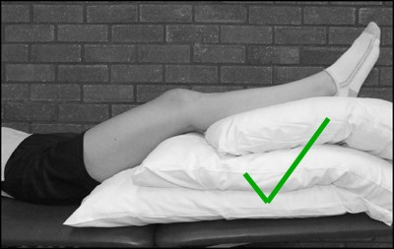
R | REST  - Rest in between walking and daily activities  - Get a good night’s sleep-important for healing!  - Sleep with the leg elevated! You may also sleep on your operative side with the knee STRAIGHT (only if having back pain or need a break)
R | ROM-Range of Motion  - Do your ROM exercises 3 times per day  - Increase ROM daily within pain limits  - DO NOT perform Squats, Lunges, exercise machines or weights | 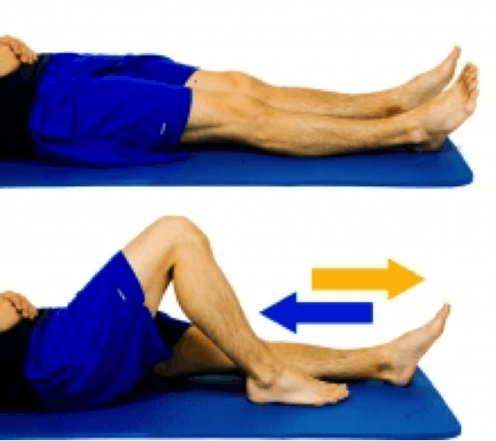 | 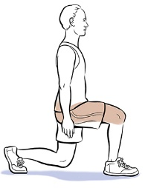
I | Ice  - Ice 4-5 times/day for 20-30 minutes, combined with elevation  - Best after walking and/or exercises  - Ice right away if soreness or swelling increases | 