Department of Family Medicine – Research Unit

BLANKET AGREEMENTS
If you plan to work with or order materials from a vendor/supplier that will provide regular/repeated goods or services to our department, the University recommends that we create (or utilize and existing) blanket agreement. This means the University will create a contract with the supplier and agree to terms and conditions ahead of time. Then, each time we want to engage with the supplier throughout the year, we can release a certain amount of funds from the existing blanket order, instead of creating an order from scratch which requires AP/Purchasing to establish a new contract each time.
Please note that several suppliers already have an existing blanket agreement with the University (follow the link for the full list of suppliers). These campus-wide agreements are called K-class or K-blankets.

How to Pay a Vendor from a Blanket Agreement:
- Check to see if the supplier you want to use has an existing blanket agreement with the University (K-class). If yes:
  - Check to see if the supplier is a BruinBuy Supplier.
    - If yes, you should submit a Purchase Request Form to order the item/service. Our purchaser will then place the order directly with the supplier and charge it to the appropriate FAU. These types of orders are called “Supplier Site Orders.” You will not need to contact the vendor to give them the PO or request an invoice, your order will be submitted directly to the supplier and the charge will be paid directly.
    - If the supplier has an existing blanket but is NOT a BruinBuy Supplier, you will need to submit a Purchase Request Form noting the Agreement number in the comments section.

- If the supplier does not have an existing blanket, then we can create our own blanket (J-class order). To do this we will need a Purchase Request Form noting the request for a J-class order. The total on the form should be an estimate of how much you plan to purchase from this vendor over the course of a year. You do NOT need to list a specific FAU. In addition to the request form, Purchasing will also require supporting documentation, so please attach the following with your PO Request Form:
  - A quote or price list
  - The vendor’s Terms & Conditions

- Once a J-class blanket has been created, Valencia will inform you of the J-class agreement number. This J-class agreement will be good for 1 year from the date of creation. You will need to keep track* of your J-class agreement numbers, the expiration date, and the amount remaining.

- Each time you need to place an order, please submit a new Purchase Request Form noting the J-class agreement number and specifying which FAU you would like to charge. This will be paid from the J-class agreement you already established. These payment requests from J-class agreements are called A-class orders. You should update your files* to subtract each of these types of A-class orders from your J-class total to make sure you have enough funds remaining.

- If your J-class has run out of funds prior to the expiration date and you plan to place more orders with that vendor, a change order (POCR) is possible. Submit a new Purchase Request Form requesting to add additional funds to the existing J-class. You do not need to specify the FAU to add funds.

*EXAMPLE OF TRACKING:

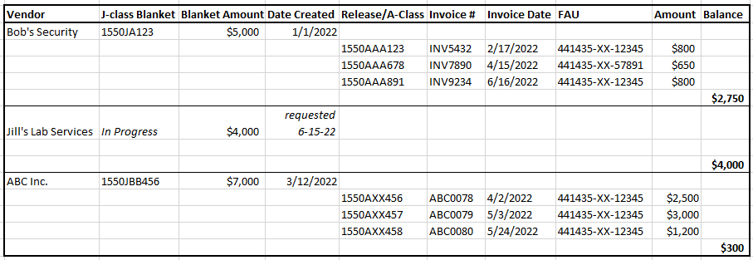
In this sample, you can see that the J-class blanket for Bob’s Security is in good shape. About half-way through the year there is still about half of the money remaining. Alternatively, ABC Inc. is running low on remaining funds and doesn’t expire for several months. Given the history of invoices, the owner of this fund should likely consider submitting a request to add funds to the J-class blanket for ABC Inc. so that future invoices will have enough funds available to be paid.

