Epistaxis Notes
General definitions:
- Anterior epistaxis: More than 90% of episodes of epistaxis occur along the anterior nasal septum at Kiesselbach's plexus/area¹
- Posterior epistaxis: Approximately 10% of nosebleeds occur posteriorly, along the nasal septum or lateral nasal wall
Approach to a patient with epistaxis:
- Causes:
  - Digital trauma
  - Topical nasal medications (antihistamines, corticosteroids)
  - Trauma
  - Dehumidification
  - Rhinosinusitis
  - Neoplasms (recurrent unilateral epistaxis)
  - Sinusitis
  - Coagulopathies/systemic conditions (45% of hospitalized patients) ²
    - In patients without systemic conditions or coagulopathies, coagulation profile testing is generally not helpful
  - Anticoagulant medication (also remember alternative therapies – garlic, ginkgo, ginseng)
  - Hypertension
- Other points in history:
  - Laterality, duration, frequency, severity, family history
Management of anterior epistaxis:
Krempl and Noorily (1995) found that amongst ED patients with epistaxis, 65% were successfully managed with oxymetazoline (Afrin). An additional 18% were managed successfully with Afrin and silver nitrate. 17% of patients required nasal packing.
- Secure airway and hemodynamic stability (ABCs!)
- Conservative/Medical management – most anterior nosebleeds are self-limited!
  - Local pressure to upper lateral cartilages for 10-15 mins while sitting forward (Baileys Ch 32)
  - Topical anesthetic and vasoconstrictors (ie – Afrin)
  - Pledgets
- Local cauterization
  - Silver Nitrate – useful adjunct to the above conservative strategies
    - Only one side of the septum is cauterized at a time to reduce risk of septal perforation.
    - Mild active bleeding or after active bleeding has resolved, but there are prominent vessels on exam
    - Separate bilateral septal chemical cautery by 4-6 weeks ¹
- Floseal (gelatin-thrombin matrix)
  - Angle towards the sphenopalatine area, apply close to bleeding source, fill nasal cavity, hold pressure
  - Found to be more effective, safe, and better tolerated than nasal packing ³
- Anterior nasal packing
  - Nasal packs coated in topical antibiotic ointment or oral antibiotics may be used to prevent toxic shock syndrome. Very low incidence of TSS, thus there is limited evidence to support the use of antibiotics with nasal packing. Weigh risk vs benefit of antibiotics.
  - Absorbable packing
    - Nasopore
    - Surgicel/Gelfoam “burrito”
    - Conform to the structure of the nasal cavity, easy to use
    - May be more costly
    - Wang et al (2014) found that nasopore is superior to merocel in regards to in situ pain, pain and bleeding with removal. No difference in nasal obstruction, tissue adhesion, mucosal healing ⁴
    - Less mechanical tamponade, but has more direct contact with areas of bleeding (Bailey’s Ch 32)
  - Non-absorbable packing (left for 1-3 days)
    - Successful in 60-80% of epistaxis refractory to vasoconstrictors and local pressure
    - Length of packing 3, 4, or 5 days had no significant impact on recurrence ⁵
    - Insertion and removal of packing can result in mucosal trauma, leading to recurrent bleeding or pain
    - Merocel/Epistat (Medtronic)
      - Has been found to have a higher pain potential and higher rate of bleeding compared to Vaseline gauze, splints, and merocel in a glove finger following septoplasty ⁶
    - Rapid Rhino
      - Found to be easier to use and more comfortable compared to merocel ⁷
    - Vaseline Gauze
      - Per Emedicine: “Prepare a length of ribbon gauze impregnated with petrolatum jelly. Use bayonet forceps and a nasal speculum to place the gauze in a layered, accordion fashion, packing it from anterior to posterior (see the image below). The gauze should be placed as far posteriorly as is possible.” ⁸
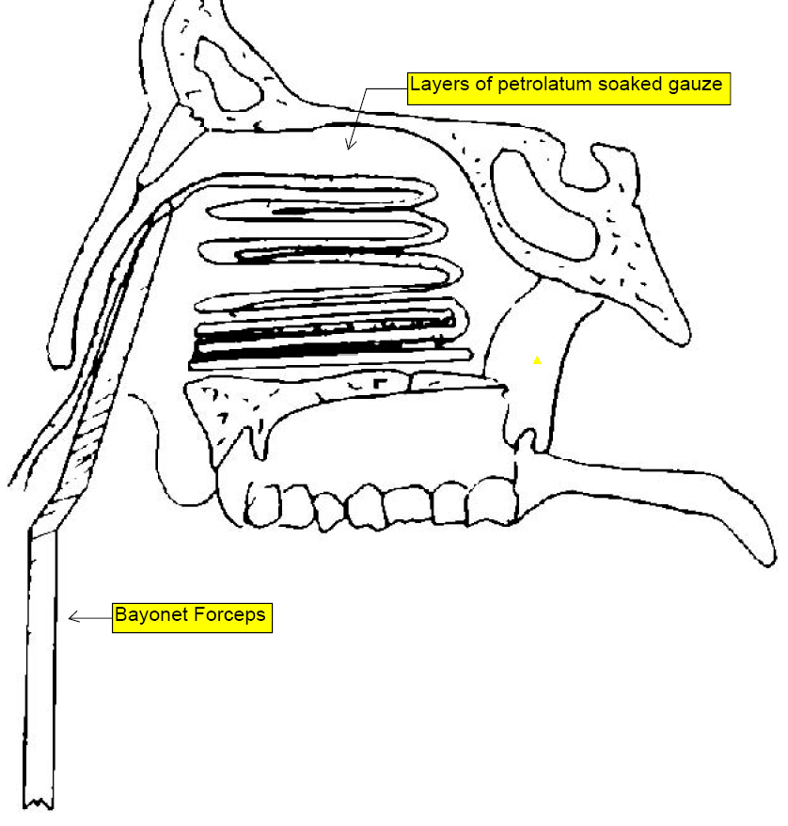
Management of posterior epistaxis:
- Transpalatal injection of SPA (through descending palatine foramen medial to upper second molar) ¹
- Posterior packing
  - Foley catheters, Epistat (Medtronic) ⁹
  - 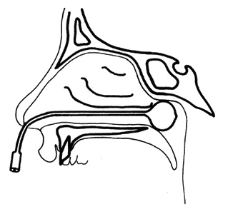
  - Must provide tamponade in the area of the choanae and sphenopalatine foramen
  - Countertraction is provided by securing posterior pack in the vicinity of the nasal ala
  - Complications: Re-bleeding, alar necrosis
  - Emedicine: “Admit all patients with posterior packing to the hospital for observation. Reflex bradydysrhythmia can develop because of stimulation of the deep posterior oropharynx by the packing. Airway compromise may develop. Posterior packing should be removed in 72-96 hours. “ ⁹
- Floseal
  - Use of floseal with ipsilateral choanal occlusion, 20 patients were discharged after 2 hours ¹⁰
  - In a study of 101 adults, Floseal was successful in 66% of anterior epistaxis cases and in only 9% of posterior epistaxis cases. There was a significantly higher failure rate of FloSeal compared with nasal packing in posterior epistaxis (p < 0.001). ¹¹
- Costs have been reported to be 50% decreased by posterior packing for immediate control followed by embolization or ligation (ie – decreased hospital stay) suggesting early operative intervention ¹²
Surgical/interventional approaches:
Pollice and Yoder (1997) found that 83% of patients with epistaxis in a hospital setting can be managed without surgery or embolization. However, patients may tolerate surgical/IR management much better and this may be the preferred route.
- IMA ligation
  - Caldwell-Luc vs Endoscopic approach
  - 90% success rate (Cummings Ch 45)
- Anterior/posterior ethmoid ligation
- Endoscopic SPA ligation (ESPAL)
  - Clipping or diathermy of the sphenopalatine artery
  - Lower morbidity compared to IMA ligation or external carotid artery ligation
  - Success has been reported at 92-100%
  - Anterior branch is clipped posterior to the crista ethmoidalis
  - There are anatomical variations in the SPA branching pattern
- Embolization
  - Risks (4%) – stroke, facial paralysis, blindness, nephropathy, seizures
  - Success has been reported at 80-90%
  - Requires interventional radiology which is not always available
  - Very effective for epistaxis supplied by external carotid artery branches and very high risk for internal carotid artery branches
- Embolization vs SPA ligation
  - Leung et al (2015) found that treatment algorithms of packing or transnasal endoscopic SPA ligation prior to embolization has the lowest patient risk, they recommend SPA ligationposterior packing embolization ¹³
  - Rudmik and Leung (2014) found that SPA ligation in experienced hands is a more cost-effective strategy compared to IR embolization for intractable epistaxis ¹⁴
References:
1. Schlosser RJ. Epistaxis. N Engl J Med. 2009;360(8):784-789. doi:10.1056/NEJMcp0807078.
2. Awan MS, Iqbal M, Imam SZ. Epistaxis: when are coagulation studies justified? Emerg Med J EMJ. 2008;25(3):156-157. doi:10.1136/emj.2006.038828.
3. Mathiasen RA, Cruz RM. Prospective, randomized, controlled clinical trial of a novel matrix hemostatic sealant in patients with acute anterior epistaxis. The Laryngoscope. 2005;115(5):899-902. doi:10.1097/01.MLG.0000160528.50017.3C.
4. Wang J, Cai C, Wang S. Merocel versus Nasopore for nasal packing: a meta-analysis of randomized controlled trials. PloS One. 2014;9(4):e93959. doi:10.1371/journal.pone.0093959.
5. Shargorodsky J, Bleier BS, Holbrook EH, et al. Outcomes Analysis in Epistaxis Management Development of a Therapeutic Algorithm. Otolaryngol -- Head Neck Surg. 2013;149(3):390-398. doi:10.1177/0194599813492949.
6. Acıoğlu E, Edizer DT, Yiğit Ö, Onur F, Alkan Z. Nasal septal packing: which one? Eur Arch Oto-Rhino-Laryngol Off J Eur Fed Oto-Rhino-Laryngol Soc EUFOS Affil Ger Soc Oto-Rhino-Laryngol - Head Neck Surg. 2012;269(7):1777-1781. doi:10.1007/s00405-011-1842-1.
7. Badran K, Malik TH, Belloso A, Timms MS. Randomized controlled trial comparing Merocel and RapidRhino packing in the management of anterior epistaxis. Clin Otolaryngol Off J ENT-UK Off J Neth Soc Oto-Rhino-Laryngol Cervico-Facial Surg. 2005;30(4):333-337. doi:10.1111/j.1365-2273.2005.01019.x.
8. Anterior Nasal Packing for Epistaxis. August 2014. http://emedicine.medscape.com/article/80526-overview. Accessed March 31, 2015.
9. Posterior Epistaxis Nasal Pack. November 2014. http://emedicine.medscape.com/article/80545-overview. Accessed March 31, 2015.
10. Kilty SJ, Al-Hajry M, Al-Mutairi D, et al. Prospective clinical trial of gelatin-thrombin matrix as first line treatment of posterior epistaxis. The Laryngoscope. 2014;124(1):38-42. doi:10.1002/lary.24240.
11. Khan MK, Reda El Badawey M, Powell J, Idris M. The utility of FloSeal haemostatic agent in the management of epistaxis. J Laryngol Otol. March 2015:1-5. doi:10.1017/S0022215115000663.
12. Moshaver A, Harris JR, Liu R, Diamond C, Seikaly H. Early operative intervention versus conventional treatment in epistaxis: randomized prospective trial. J Otolaryngol. 2004;33(3):185-188.
13. Leung RM, Smith TL, Rudmik L. Developing a Laddered Algorithm for the Management of Intractable Epistaxis: A Risk Analysis. JAMA Otolaryngol-- Head Neck Surg. February 2015. doi:10.1001/jamaoto.2015.106.
14. Rudmik L, Leung R. Cost-effectiveness analysis of endoscopic sphenopalatine artery ligation vs arterial embolization for intractable epistaxis. JAMA Otolaryngol-- Head Neck Surg. 2014;140(9):802-808. doi:10.1001/jamaoto.2014.1450.

