Purpose: This document provides guidance for new hire care partners to complete the UCLA Health required initial competencies.
The onboarding process is designed to help new hires learn the culture of the organization, work environment, and available resources. The New Hire Requirements website contains the onboarding and orientation requirements for new hires.
The New Hire Requirements site contains the New Hire Toolkit (evaluations/feedback tools), Department Unit Orientation Checklist, Required Education, and Initial Competencies for Clinical Administrative Care Partner (CACP) and Clinical Care Partner (CCP) | 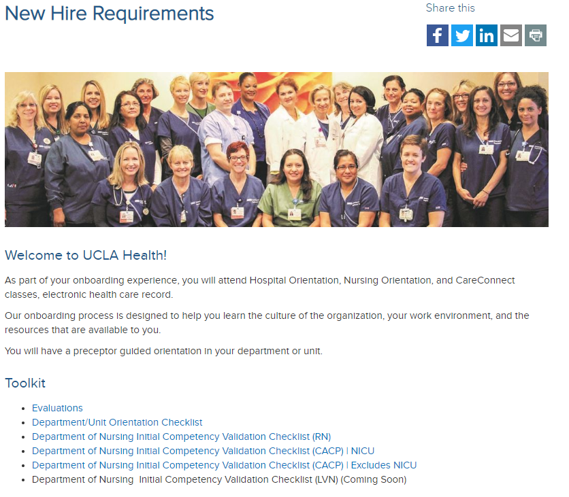  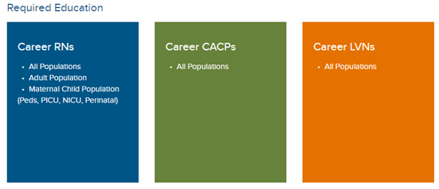
The Evaluations link contains the new hire feedback and preceptor evaluation tools.

The Daily New Hire Feedback Form and Weekly New Hire Feedback Form are utilized to individualize the new hire’s orientation. The feedback forms are completed by the preceptor and shared with the new hire and unit leadership.  The Preceptor Evaluation (for New Hire) and the Preceptor Evaluation (for Unit Leadership) are utilized to provide preceptor feedback. | 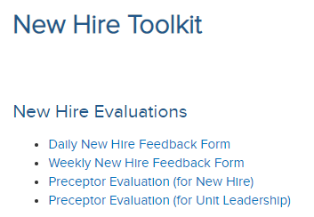
The UCLA Department/Unit Orientation Checklist contains the regulatory and department/unit orientation requirements.
The evaluator must complete all sections of the Department/Unit Orientation Checklist before the new hire independently provides care or service (no later than the first thirty days of employment). | 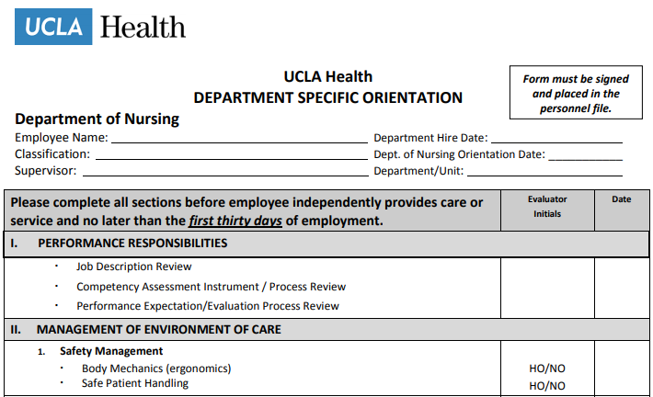
The All Populations site contains the new hire CACP/CCP required education for all patient populations.
The All Populations site contains hyperlinks to complete the required education in Cornerstone. Please review the requirements with your new hires.

An Initial Competency Assessment will be performed for all staff at the point of hire or transfer to a new position. The Department of Nursing Initial Competency Validation Checklist (CACP) | NICU and the Department of Nursing Initial Competency Validation Checklist (CACP) | Excludes NICU  Competency Assessment must be determined to be satisfactory and signed by the employee and preceptor or supervisor no later than six months from the date of hire or transfer. | 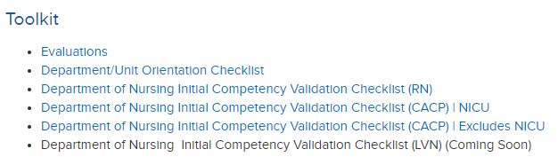
The Department of Nursing Initial Competency Validation Checklist (CACP) | NICU and the Department of Nursing Initial Competency Validation Checklist (CACP) | Excludes NICU contains competencies (skills) the new hire CACP/CCP must independently demonstrate which are required to provide safe patient care. | 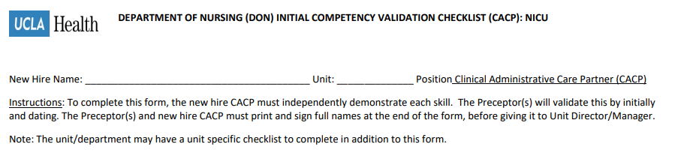  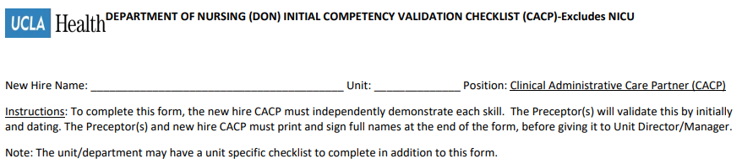

For questions, contact:
Kristine Traxler, MSN-Ed, RN
Nursing Professional Development Specialist
Center for Nursing Excellence
Phone: 424-259-9272
Cell Phone: 310-623-2591
KTraxler@mednet.ucla.edu

