Purpose: This document provides guidance for new hire nurses to complete the UCLA Health required initial competencies.
The onboarding process is designed to help new hires learn the culture of the organization, work environment, and available resources. The New Hire Requirements website contains the onboarding and orientation requirements for new hires.
The New Hire Requirements site contains the New Hire Toolkit (evaluations/feedback tools), Department Unit Orientation Checklist, Required Education, and Initial Competencies for Licensed Vocational Nurses (LVN). | 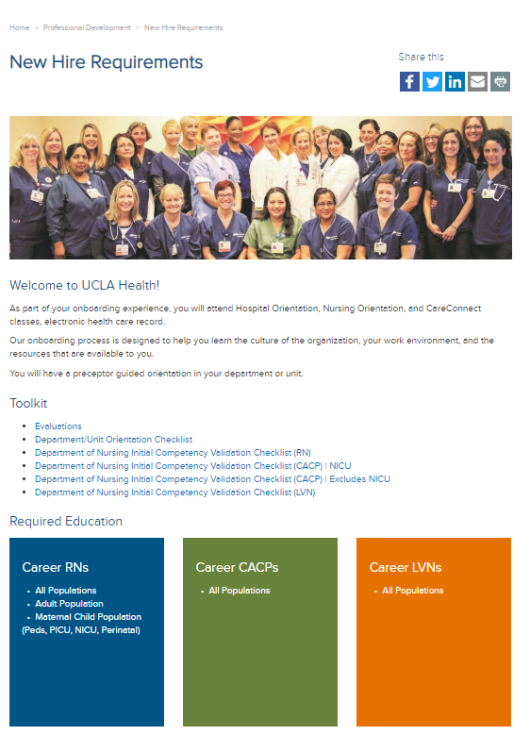
The Evaluations link contains the new hire feedback and preceptor evaluation tools.

The Daily New Hire Feedback Form and Weekly New Hire Feedback Form are utilized to individualize the new hire’s orientation. The feedback forms are completed by the preceptor and shared with the new hire and unit leadership.  The Preceptor Evaluation (for New Hire) and the Preceptor Evaluation (for Unit Leadership) are utilized to provide preceptor feedback. | 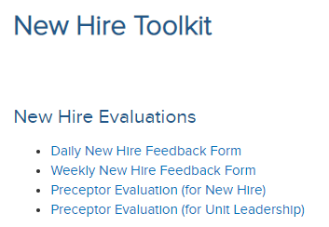
The UCLA Department/Unit Orientation Checklist contains the regulatory and department/unit orientation requirements.
The evaluator must complete all sections of the Department/Unit Orientation Checklist before the new hire independently provides care or service (no later than the first thirty days of employment). | 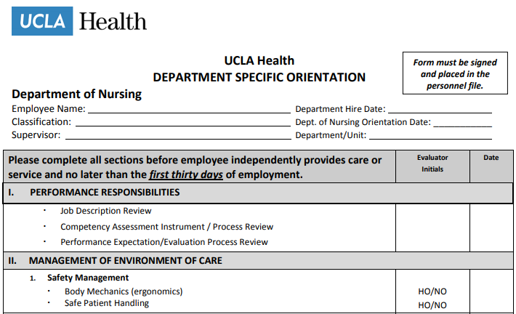
The All Populations site contains the new hire LVN required education for all patient populations.
The All Populations site contains hyperlinks to complete the required education in Cornerstone. Please review the requirements with your new hires. | 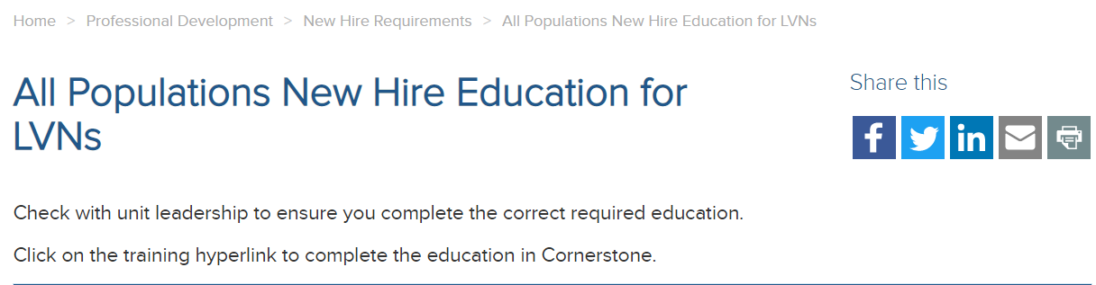
An Initial Competency Assessment will be performed for all staff at the point of hire or transfer to a new position. The Initial Competency Validation Checklist (LVN) Competency Assessment must be determined to be satisfactory and signed by the employee and preceptor or supervisor no later than six months from the date of hire or transfer. | 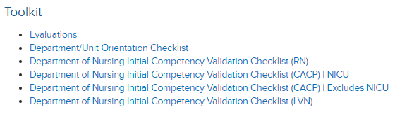
The Initial Competency Validation Checklist (LVN) contains hyperlinked competencies to complete the knowledge, skills, and attitude (KSA) required to provide safe patient care. The individual hyperlinked KSAs contain direct links to policy/procedures, forms portal, Lippincott Procedures, and required education. | 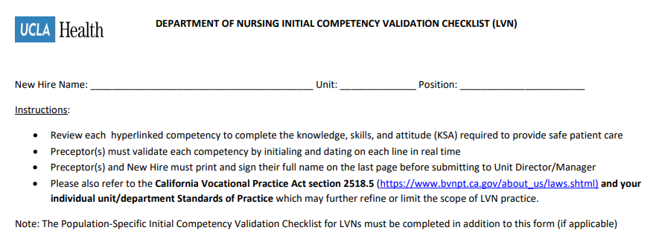

For questions, contact:
Kristine Traxler, MSN-Ed, RN
Nursing Professional Development Specialist
Center for Nursing Excellence
Phone: 424-259-9272
Cell Phone: 310-623-2591
KTraxler@mednet.ucla.edu

