Adam Sassoon, M.D.
UCLA Department of Orthopaedic Surgery
1225 15th Street, Suite 3145
Santa Monica, CA 90404
Office # (424) 259-9872 / Fax # (424) 259-6599

Total Knee Replacement Post-Operative Patient Instructions

Incision Care
If you have a special PICO wound vac dressing, you can remove dressing 7 days from surgery and okay to remain uncovered, UNLESS you have a follow up appointment with Jennifer Lew or Dr. Sassoon 1 week for wound assessment and possible placement of new PICO dressing. If you have a follow up appointment within 1 week from surgery, please do not manipulate dressing. Example of PICO wound vac dressing below:

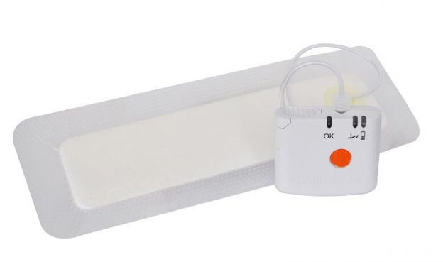

Please do not put soap directly on incision and DO NOT REMOVE MESH TAPE OVER SURGICAL INCISION. Mesh tape will fall off on its own after 7 to 14 days. Examples of mesh tape over dressing below:

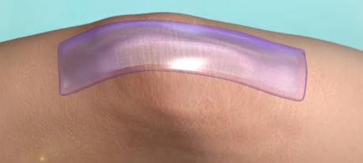

Swelling and bruising
After surgery swelling and bruising of the operative leg is normal and will gradually decrease as the days pass. If activity and exercise worsens your swelling take time to lie down and elevate your leg above the level of your chest, especially for the first two weeks from surgery. Ice packs also help diminish the swelling.

Ice
You should place an ice pack over the anterior (front) of the operative knee 3 times a day for 20-30 minutes at a time. You may use an ice pack more frequently if you like. Using ice is most important during the first 2 weeks from surgery.

Pain relief
It is normal to have some pain after surgery. We will prescribe enough pain medication to cover you beyond your next office visit. It should be noted that pain medications take about one-half hour to start working, so take them prior to the pain becoming severe. DO NOT drink alcohol while taking prescribed pain medication. It is dangerous and illegal to drive while taking pain medicine. If you need a refill on pain medication before your first scheduled appointment, please call our office during regular office hours. Please provide at least 3-day notice as to when you will be running out of narcotic pain medication

DVT (Blood Clot) prophylaxis
You will be prescribed a medication to lower your risk of forming blood clots. This medication is important to take until the prescription is finished. Depending your risk factors for blood clots and prior medical history, these may include Baby Aspirin 81 mg, Xarelto, Eliquis. You will be given instructions and a prescription on which blood thinner you will be taking prior to discharge from the hospital. In addition, being active and performing your exercises properly can minimize your risk.

Activity
For the first few weeks after surgery, walk as much as possible without overdoing it. You are weight bearing as tolerated which means you are allowed to put as much weight on the operative leg as is comfortable. Let pain be a guide, keeping in mind that you just had surgery. You will be given home exercises to be done on a daily basis. After the initial post-operative phase, we will gradually progress your activities. However, initially, it is extremely important that you exercise your new joint by walking. Remember that exercise and activity is important to prevent the formation of blood clots.

You should work on bending the knee (flexion) by following the exercises you learned from the physical therapist in the hospital. The amount of flexion should be increased by 5-10 degrees each day, with the goal being to achieve 120 degrees of flexion. When not working on bending the knee, you should place a small towel roll or folded pillow behind your Achilles tendon (just above your heel, but not on the heel) to help achieve full extension (straightening). You should do this exercise also 3-4 times per day, for about 30 minutes at a time. IT IS CRUCIAL THAT THE LEG ACHIEVES FULL EXTENSION DURING THE FIRST 2 WEEKS FROM SURGERY. Please report to Wilson, Nurse Navigator is this is not achieved.

You may also work on lifting your leg off the table with the knee straight. This is called isometric strengthening. You do not need to use any weights; the weight of your leg itself will help strengthen the quadriceps muscle.

Assist devices
You will be discharged from the hospital with a walker, crutches or a cane depending on how well you walk with physical therapy as an inpatient. You will typically use these aids anywhere from a few days to a few weeks and stop using them when you are stable and strong on your feet. Some people who have used these devices for years may require prolonged use for reasons unrelated to the surgery.
Driving
You may drive when you have good control over the operative leg, can effectively slam on the breaks if necessary to stop vehicle, and are no longer on pain medicine.

Diet
Typically, with adequate protein intake for promotion of healing, there are no special diet restrictions. Make sure you eat a well-balanced meal, drink plenty of fluids and incorporate fiber into your diet as oral pain medications have a tendency to cause constipation. It is also a good idea to take a stool softener such as Colace daily until your system becomes regular after surgery. If you are prescribed Coumadin, you will be given a separate handout on Coumadin and avoiding foods high in Vitamin K (which can inhibit the Coumadin from working effectively).

Home Healthcare
A home healthcare company will be set up (prior to your discharge from the hospital) to set up a home visiting nurse and home physical therapist. The nurse and the physical therapist each typically come to your house 3 times a week for an hour at a time. They usually come or 2-3 weeks at which point you will be transitioned to an outpatient physical therapy facility.

Dental work after joint replacement
Artificial joints can become infected after simple procedures such as dental cleaning. Preventative treatment is extremely important and should be followed prior to receiving any dental treatment. Please call us, or your dentist ahead of time so that an antibiotic can be prescribed before you have your dental work done. YOU SHOULD NOT HAVE ELECTIVE DENTAL WORK PERFORMED FOR 3 MONTHS FOLLWING YOUR JOINT REPLACEMENT DUE TO THE INCREASED RISK FOR INFECTION. If a dental crisis occurs within this time period, please call our office for instructions.

Antibiotic Prophylaxis:
Although it is very rare, an artificial joint can become infected by the bloodstream carrying infection from another part of the body. Therefore, it is important that your medical doctor treat any bacterial infection (pneumonia, urinary tract infection, and abscess) promptly. Routine colds and flu as well as cuts and bruises do not need to be treated with antibiotics.

Patients should take Amoxicillin: 2 grams by mouth one hour before having any of the following procedures:
- Routine dental cleaning
- All other dental procedures
- Skin biopsy or other Dermatologic procedure that involves cutting into the skin
- Podiatry procedures which involve cutting into the skin
- Colonoscopy, Endoscopy, Cystoscopy (let your doctor who is performing this procedure know ahead of time, they may prefer giving antibiotics intravenously prior to the procedure instead of by mouth)
- Invasive gynecological procedure (let your OB/GYN doctor who is performing this procedure know ahead of time, they may prefer giving antibiotics intravenously prior to the procedure instead of by mouth)

If you are unable to take Amoxicillin (Penicillin allergy) use Clindamycin 600mg by mouth one hour prior to the procedure. If you have allergies to both, please consult your surgical team.

Post-operative office appointment
Your first postoperative visit will be between 7-14 days after the surgery. You will then be seen again at 6 weeks, 12 week, and then 1 year after surgery. Your first post-operative visit should be set prior to your surgery.

Post-operative X-rays
X-rays are obtained immediately after your surgery in the hospital. You will typically get additional X-rays at your subsequent visits to evaluate the knee replacement components for wear, loosening and other possible abnormalities.

Call the Ortho Nurse Navigator Wilson Phoeng (310) 295-7403
OR the Office (424) 259-9872 if you notice any of the following:
- Fever above 101° Fahrenheit
- Persistent swelling, redness, or uncontrolled pain in the surgical area
- Persistent bleeding or drainage from the wound
- Severe calf pain or tenderness
- You are unable to do the exercises
Call 911 if you have a sudden crisis such as symptoms of a heart attack, stroke, dizziness or confusion, or chest discomfort or pain.
If you have any questions and concerns about any discharge instructions, recovery process, and rehab please contact Ortho Nurse Navigator - Wilson Phoeng @ (310) 295-7403
