UCLA Family Medicine - TRAVEL
BOOKING AIRFARE AND PRE-PAYING FOR HOTELS:
NOTE: if you are trying to book for a guest, please refer to the Guest Traveler Request Form instead
- If you are not the PI, you must obtain Authorizer/PI approval prior to proceeding. The PI/Authorizer needs to approve the purpose for the travel, and confirm the funding source (FAU) to pay for the travel.

- Once you have Authorizer approval, now you need to create a draft itinerary for your flight (and/or hotel).
You can reserve a flight yourself using the SAP Concur website or by calling UC Travel at 310-206-2639 and having a Travel Agent create the itinerary for you. It won’t be final until you pay for it, which requires a Concur Request ID (also known as PTA). See the next heading for more information on obtaining a Concur Request ID/PTA.
You can also book and direct bill* for hotel, but you cannot use the self-service Concur website for that. You need to call UC Travel and work with an agent.
Once you have spoken with a Travel Agent, a draft itinerary will be emailed to you. (If you are booking using the self-service SAP Concur website, you will create the itinerary yourself). You will need your itinerary for the next step.
*Direct Bill is a payment option where expenses are charged directly to your department with no out-of-pocket cost to the traveler. This is only available for airfare or lodging booked through the UC Travel Center, either with the Concur Online Booking Tool or with agent assistance. An approved request is required and a service fee will apply. After the travel is booked, the Direct Bill charges will appear as Company Card transactions and must be attached to an expense report along with the associated approved request. The transactions should be attached as soon as they are available, but the expense report cannot be submitted until after completion of the trip.
3. To request a Concur Request ID/PTA, you will need to email the following information to your fund manager and Valencia. If either one of them are out of the office, cc Laura (she is the back-up for both):
- FAU (account, cost center, and fund #) (If you don’t know the FAU, please explain what funding source you would like to use)
- Business Justification for the travel (please avoid jargon and use language that can be copied and pasted directly into the system. E.g. don’t say “I just want to pay for my trip to SD conference next month,” but rather: “Roundtrip airfare for Dr. Josephine Bruin to Washington DC to attend the Scientific Development conference October 2-5, 2022.”)
- Forward a copy of the Travel Itinerary you received from UC Travel or the Concur Website
Once your fund manager approves the funding source, Valencia will enter it into the system and then submit it directly to the travel system online for processing. You will then receive confirmation of the finalized itinerary via email, once Travel has received/approved the submitted Concur Request ID/PTA.
Now you are ready to travel!
DURING/AFTER TRAVEL:
- While traveling, please retain your receipts. Within 5 days of your return, you should submit your receipts along with your completed Travel and Entertainment Reimbursement Request Form to your Authorizer/PI for approval. Once approved, please email everything to your fund manager and cc Valencia. (If you have not already taken the training or if this is your first time traveling, please review the Travel/Entertainment Training (PPT) for more details about completing the Travel and Entertainment Reimbursement Request Form).
4a. NOTE: If this is your first time travelling, YOU MUST GRANT VALENCIA DELEGATE AUTHORITY IN CONCUR IN ORDER TO PROCESS YOUR REIMBURSEMENT REQUEST. You only need to do this once; this is not required each time you travel. To grant delegate authority in Concur:
Log into the SAP Concur website. Click on “Profile” in the top right and select “Profile Settings.”
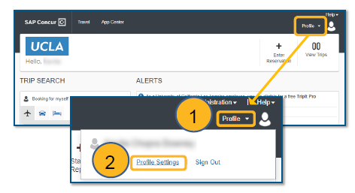
Select “Expense Delegates”
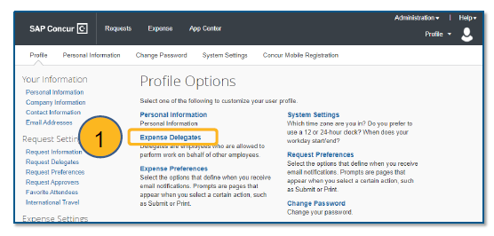
Click “add” to search for and select Valencia Moody, and then click “add” by the search field. Select all check boxes. Click “save”.
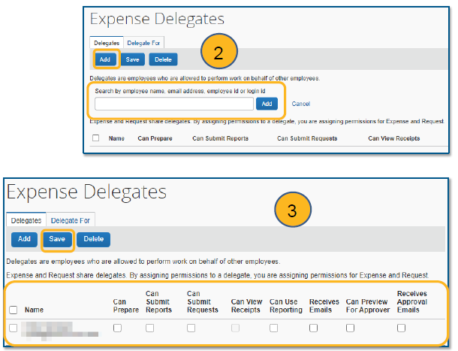
Valencia will then be able to create expense reports on your behalf.
- Once Valencia has completed your expense report, the Traveler will receive an email requesting approval/submission. YOU MUST LOG INTO THE CONCUR SYSTEM TO APPROVE AND SUBMIT YOUR EXPENSE REPORT OR YOU WILL NOT BE REIMBURSED. Expense Reports need to be approved and submitted within 30 days of travel, so you should be submitting your reimbursement as soon as possible after returning from travel. Instructions on how to approve your expense report:
From the Concur homepage, you should see any reports awaiting approval on the landing page. Or you can click on the Approvals tab at the top of the screen.
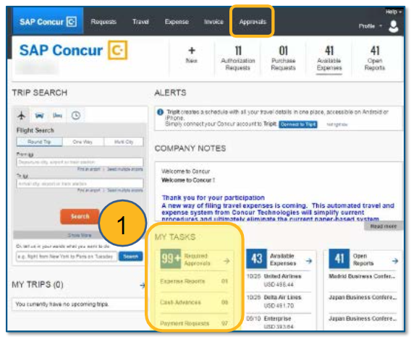
From there, navigate to your Expense Reports and click on the Report name.
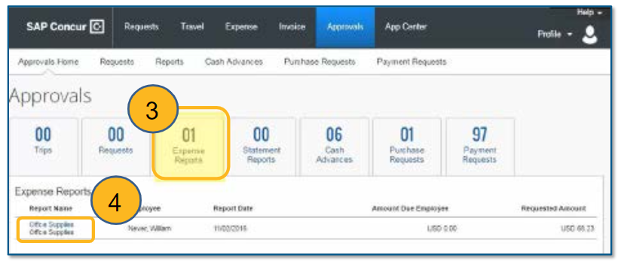
Review everything for accuracy. If everything looks acceptable, click Approve on the top right and submit.
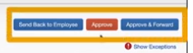
You will receive your reimbursement in the same manner in which your paycheck is distributed (e.g. if you’ve signed up for direct deposit, your reimbursement will be direct deposited).

Please contact Valencia Moody if you have any questions about the process.

